**EDUNET FOUNDATION-Class Exercise Notebook**

**LAB 2 – Registering a Raspberry PI on Cloud**

Follow the below steps to register a device on Cloud.

Step 1. Clone the below repository on RaspberryPi

<https://github.com/SoftwareAG/cumulocity-devicemanagement-docker-example.git>

Step 2.. Open repository and note down the device id

cat cumulocity-devicemanagement-docker-example/Agents/config/config.ini

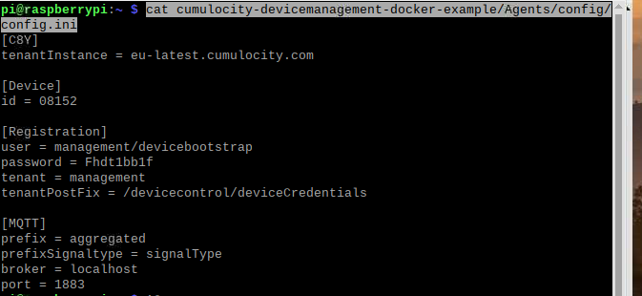

Step 3:-Then expand the 'Devices' tab in left-hand menu, go to 'Registration' and **click 'Register device'**.

[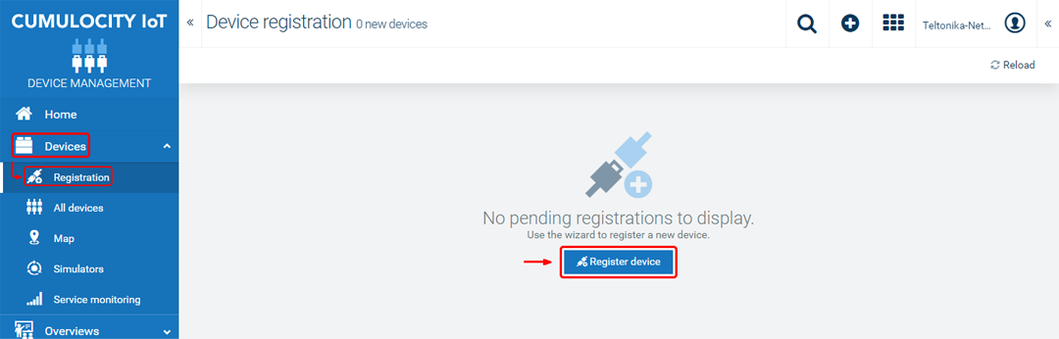](https://wiki.teltonika-networks.com/index.php?title=File:Networking_rutos_configuration_examples_cumulocity_6.png&filetimestamp=20200721101706&)

Step 4. Enter your device's serial number into the 'Device ID' field. Then it will await for device application to be turned on

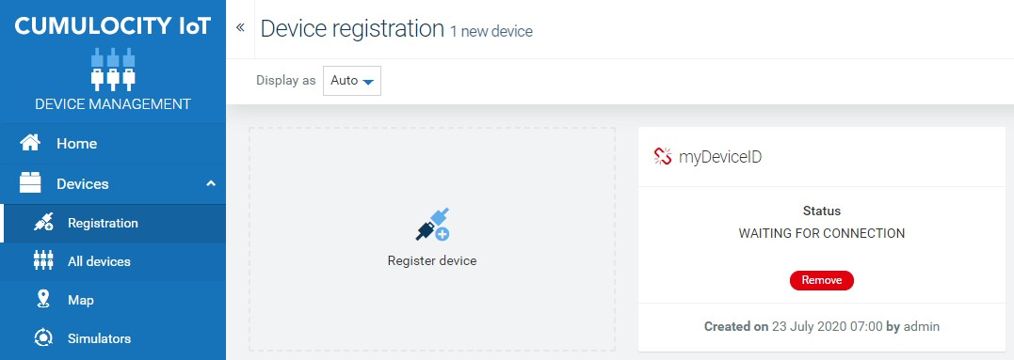

Step 5.. Run docker in Raspberry PI using below command to connect RPI to cloud

sudo bash cumulocity-devicemanagement-docker-example/start.sh

Step 6.. Refer back to dashboard to accept connection and now your device is connected to cloud.